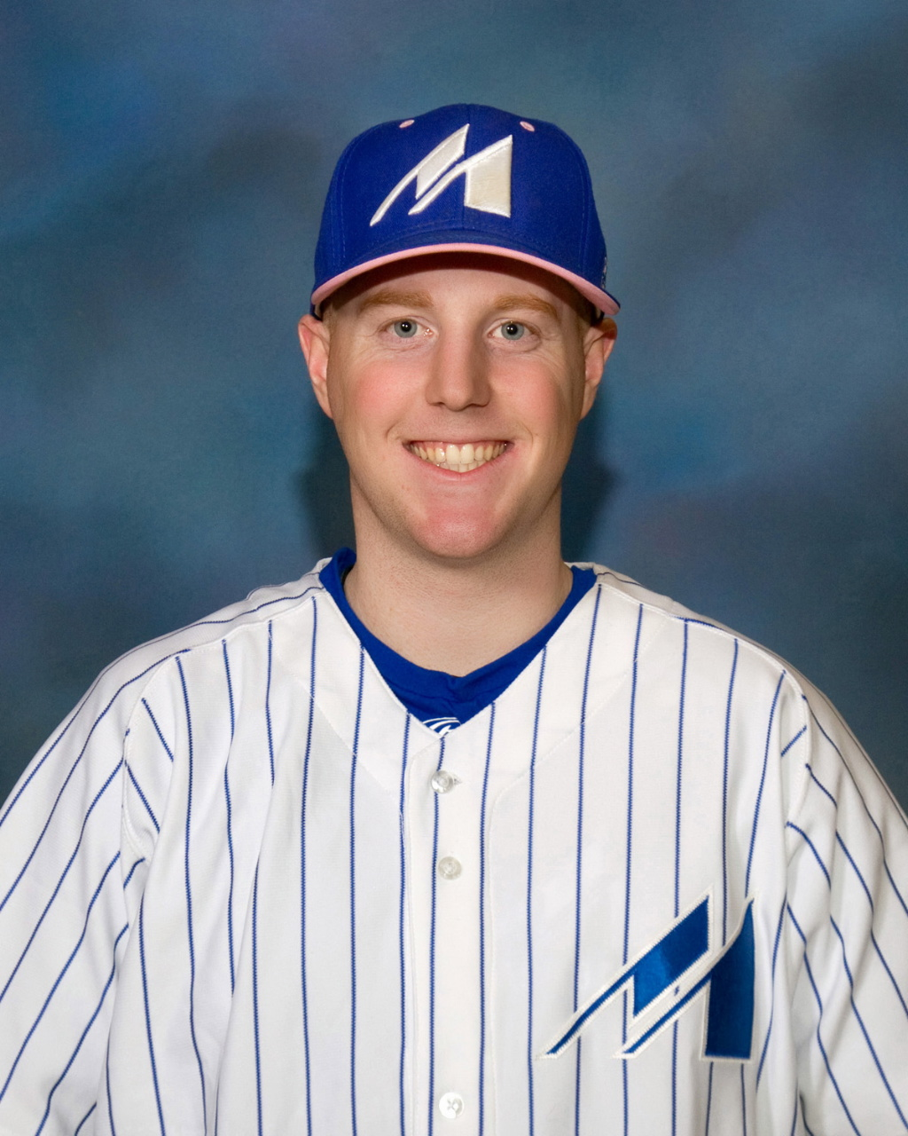
Russell is a Langley Blaze alumnus where he was a dual asset on the mound, as well as, in the field. Upon graduating, Russell received a Scholarship to pitch for Clarendon College in Texas (NJCAA DIV 1). After serving as the closer for two years, Russell transferred to Mayville State University in North Dakota (NAIA) and their pitching staff.
Russell joined the Langley Blaze as the Head Coach for the Bantam Prep age division in 2016. Development of the athletes was the main goal during the three seasons he coached with the Blaze. Russell has an athlete first approach where communication of goals is key in helping them achieve success.
Career Highlights:
Region 5 All-Conference Honorable Mention (Clarendon College)
Academic All-American (Mayville State University)
2016 Provincial Champions (Langley Blaze Bantam Prep)
2016 Bronze Medal Canadian National Championships (Langley Blaze Bantam Prep)
2018 Gold Medal Western Canadian Championships (Langley Blaze Bantam Prep)

